**Homework Wan Huzaifah bin Wan Azhar**

**Answer:**



* The gettimeofday() timer is accurate to microseconds.
* Simple Google shows that this timer can only work with intervals shorter than ~2000 seconds as longer than 2000 seconds will cause arithmetic to overflow.
* It can be mitigated by multiplying seconds to 1000000LL, however.



* The measurement shows that increasing the number of threads increase the time it takes to increment counter.
* The number of CPU have an effect on the performance as using one CPU cause the time it takes to finish incrementing the counter increases.

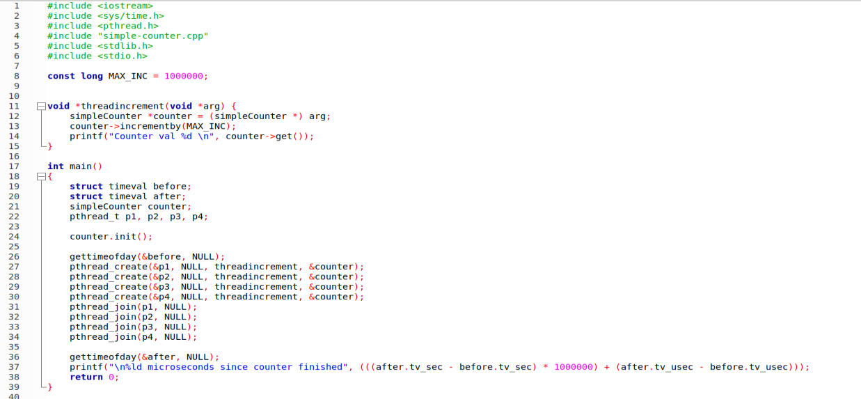

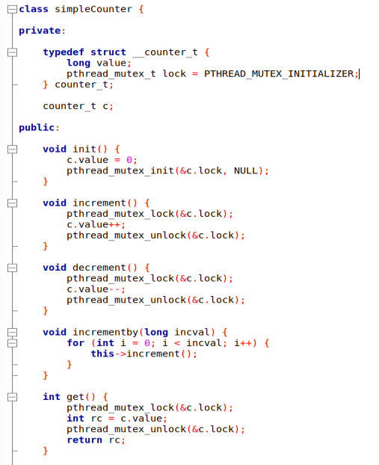



* As it can be seen, performance on one threads perform significantly better than four threads.
* Increasing threshold S does increase performance, however, the performance increases will stabilise.